Finger vein product specification

|  |  |  |  |
| --- | --- | --- | --- |
| serial number | Version | Updated | Release Notes |
| 1 | V01 | 2015.04.21 | The first version, suitable for JM128, JM110 models |
| 2 | V02 | 2017.04.28 | Add JM168 model |
| 3 | V03 | 2020.06.08 | Added JD110 model, added JD120 model |

Specifications applicable product model: JM128/JM110/JM168/JD110/JD120

For software interface, please refer to the programming manual

# Product selection table

|  |  |  |
| --- | --- | --- |
| serial number | model | Schematic |
| 1 | JM128 |  |
| 2 | JM168 |  |
| 3 | JD110 |  |
| 4 | JD120 |  |

ordering product

Product ordering instructions: JM128-1.25-500

① ② ③

①Product model: JM128

② even machine model:1.0mm pitch DH connector; 1.0mm pitch FPC; 1.25mm pitch DH connector; 1.25mm pitch FPC

③Number of finger vein users: 100/200/300/500/1000/2000/3000/5000

# Precautions

1. VCC_TP touch power supply ripple needs to be less than 20mV

2. The VCC main power supply ripple needs to be less than 30mV

3. This module needs to be kept away from metal objects and radio frequency emitting products. If the body has metal, try to isolate 5mm between the body and the module.

4. When using, the fingers are naturally straight, and ensure that the fingertips and the pulp are in contact with the front and rear sensors respectively, and do not press the fingers

5. Reserve the fingertip position when fixing the module, and design the plastic wrapping slot on the structure, so that the user can have a better experience

6. During the test, holding the module by hand will cause the module to misjudge. Please fix the module on the desktop before operating.

7. It is recommended to collect the index finger, middle finger and ring finger; preferably the second knuckle of these 3 fingers

# target record

1 Overview 6

* 1. 1 Main features 7
  2. 2 Core Algorithms 7
  3. 3 Operating system 7

2. Interface definition 7

3. Dimensions 10

3.1 Dimensions 10

JM 128 Dimensions: 10

JM 168 Dimensions: 10

4. Typical application fields 11

* 1. Device Workflow 12
     1. modeling process 12
     2. Certification process 13
  2. Instructions for using the serial port mode test tool 13
  3. 3 USB Mode Test Tool Instructions 15

## 1 Overview

The finger vein module highly concentrates the finger vein sensor and image algorithm processor in one module. Users can realize the functions of registration, verification and identification of finger veins through command control. The module can be used as a finger vein acquisition module to transmit the collected images to the host computer through USB, or it can directly complete the authentication and comparison of the collected finger vein images inside the module, and the comparison results can be output through the serial port.

### Product advantages

|  |  |  |
| --- | --- | --- |
|  |  |  |
| Ultra small size | Ultra low power consumption | Universal module |

|  |  |  |
| --- | --- | --- |
| parameter | describe | Remark |
| storage | 100~5000 pieces |  |
| Comparison method | 1:1,1:N |  |
| comparison time | 1:1 million within 1 second |  |
| Whether there is self-learning | Yes |  |
| False Recognition Rate (FAR) | <0.001% |  |
| Authenticity Rejection Rate (FRR) | <1% |  |
| interface | UART baud rate 115200 | 1 |
|  | USB 2.0 full speed interface | 1 |
| Start Time | <150ms |  |
| Supply voltage | 3.4V~5.5V |  |
| current consumption | 10uA sleep/210mA work |  |

|  |  |  |
| --- | --- | --- |
| Operating temperature | -20℃~+75℃ |  |
| storage temperature | -40℃~+85℃ |  |
| Relative humidity | 40% to 85% (non-condensing) |  |
| Finger groove antistatic ability | Metal contact discharge 8KV, non-contact discharge 15KV |  |
| vibration | 2000 G, 0.7 ms, half sinus, 3 axes |  |
| fall | Withstands a 1-meter drop to concrete |  |
| Module weight | <50g |  |
| Certification | Ministry of Public Security Certification |  |

**1.1 Main features**

Highly integrated integration, small size, high reliability; self-contained micro-system, more stable and fast;



1



2

Natural living certification, extremely difficult to steal, extremely accurate; ultra-high performance1 GHz main frequency processor;



3



4

### 1.2 Core Algorithms

Champion of the Global Finger Vein Algorithm Competition, more accurate identification.

### 1.3 Operating system

Support Windows, Linux, Andriod, Kylin, embedded and other operating platforms, can provide SDK, wide adaptability

## 2. Interface definition

Client connection port 1

|  |  |  |  |
| --- | --- | --- | --- |
| Line number | Pin name | Type | Function description |
| 1 | TXD | OUT | UART signal TX, 3.3V logic level, default baud rate 115200 |
| 2 | RXD | IN | UART signal RX, 3.3V logic level, default baud rate 115200 |
| 3 | GND | IN | Module power input GND |
| 4 | VCC | IN | module5V power input, the maximum current RMS when inputting 5V power  ≤150mA, the power efficiency is recommended to be controlled within 75%, so the power  The source current needs to be ≥210mA |
| 5 | VCC_TP | IN | module3.3V power input, the maximum operating power when 3.3V power is input  Stream 100uA |
| 6 | TP_IRQ | OUT | Vein detection interrupt signal, continuous low power when no finger is detected  Flat, output high level after detecting finger, interrupt signal time is the same as touch time |
| 7 | USB_DM | I/O | USB 2.0 DM |
| 8 | USB_DP | I/O | USB 2.0 DP |

**Illustrate:**

1. The module uses dual power supply;

2. In low power consumption scenarios, receiveTurn on the 5V power supply after TP_IRQ, and turn off the 5V power supply after receiving the authentication information, which can reduce power consumption;

3. If you don't need low power mode, you can only use 5V power supply, 3.3V pin NC (USB version only, you need to communicate with customer service in advance for the second version);

4. The test sample includes modules and test wires;

5. Port 1 wiring diagram Connector model: 1mm pitch/8pin

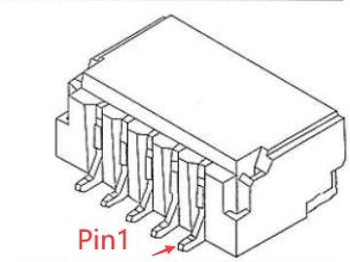

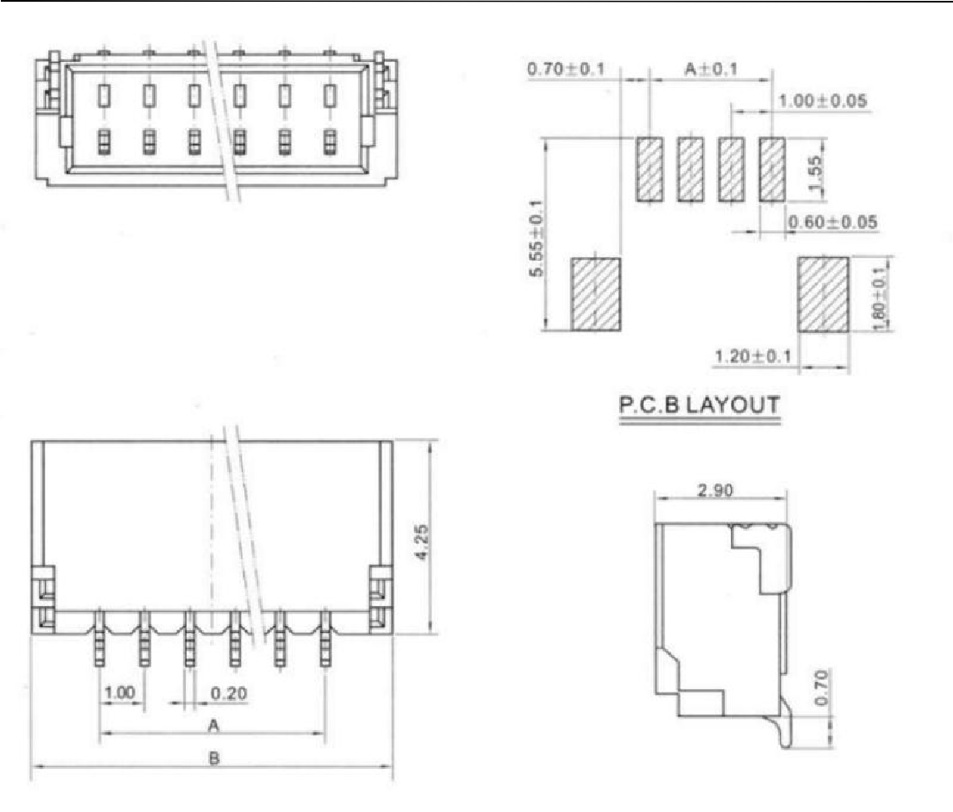

**Units are millimeters**

## 3. Dimensions

### 3.1 Dimensions

### JM 128 Dimensions:

|  |  |
| --- | --- |
| Front view | side view |
|  |  |

|  |  |  |  |
| --- | --- | --- | --- |
| serial number | Min/mm | Typical value/mm | max/mm |
| long | 48.44 | 48.74 | 49.04 |
| width | 29.50 | 29.80 | 30.10 |
| high | 30.20 | 30.50 | 30.80 |

### JM 168 Dimensions:

|  |  |
| --- | --- |
| Front view | Side view |
|  |  |

|  |  |
| --- | --- |
| top view |  |
|  |  |

|  |  |  |  |
| --- | --- | --- | --- |
| serial number | Min/mm | Typical value/mm | max/mm |
| long | 39.8 | 40 | 40.2 |
| width | 37.0 | 37.2 | 37.4 |
| high | 9.4 | 9.6 | 9.8 |

## 4. Typical application fields

Smart locks, attendance machines, safes, access control machines, etc.

### Device Workflow

### modeling process

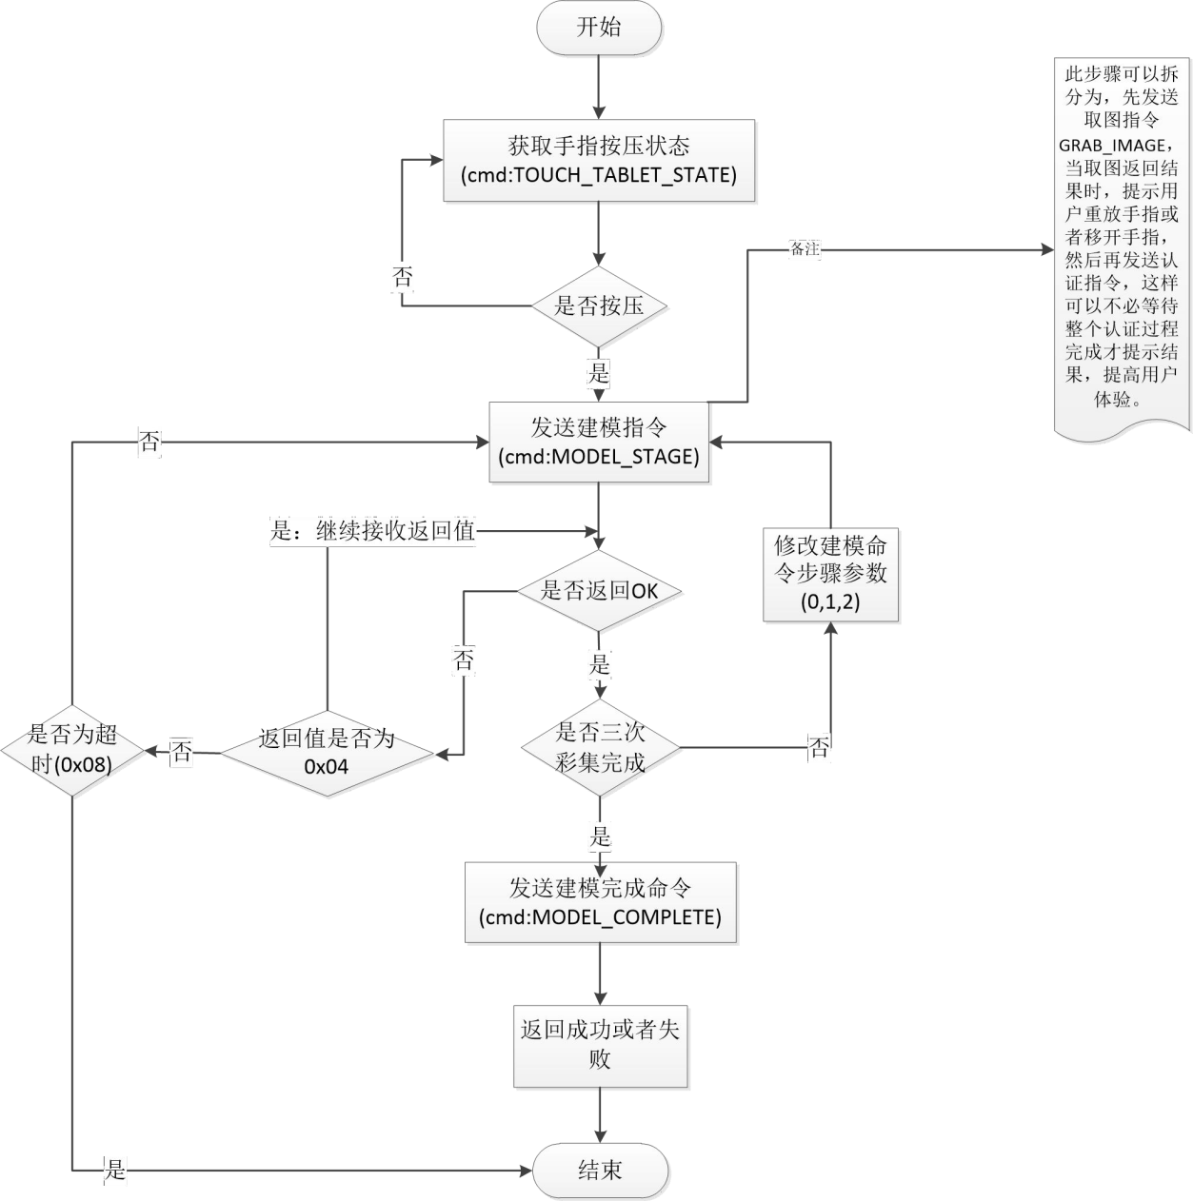

### Certification process

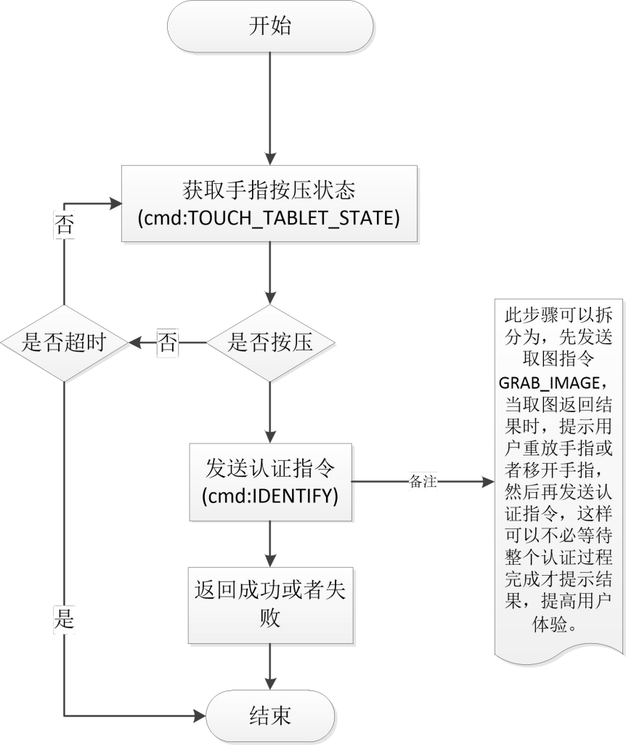

### Instructions for using the serial port mode test tool

|  |  |
| --- | --- |
| **Confirm the serial number**  1. Right-click the computer icon on the desktop, select Manage, and enter the computer management interface as shown on the right.   1. Click Device Manager to confirm the serial port connected to the device   3. If the serial port tool is not read, please use the driver wizard and other software to install the serial port driver |  |

|  |  |
| --- | --- |
| **Step 1: Modeling**  1. Follow 1 and 2 to open the serial port, open the device, and select the correct serial portand baud rate (default 115200)  2. Click to start modeling (put your finger into the finger groove, model 3 times, be careful not to press your fingers, pressing hard will cause the blood vessels to deform)  **Step 2: Authentication**  1. Follow 1 and 2 to open the serial port, open the device, and select the correct serial portand baud rate (default 115200)  2. Click to start authentication (put your finger in for authentication) |  |

Some commands require parameters, which can be entered in the command input parameter field

|  |  |
| --- | --- |
| command name | parameter |
| device id | Set device id, range (1-255) |
| baud rate | According to the level, the 13th level corresponds to 576000, the 14th level corresponds to 921600, and the 15th level corresponds to  Corresponding to 1,000,000, level 16 corresponds to 1,152,000 |
| usb mode | Switch the device to usb mode |
| Serial mode | Convert the device to serial mode |
| delay | Timeout for modeling and authentication (in seconds, default 10) |
| Duplicate registration | Whether to check the same person logged in, default 1(0,1) |
| Same finger check | Whether to check the same finger when modeling, the default is 1(0,1) |
| finger state | Returns the current finger state |
| Clear specified user information | userid |
| Clear all user information |  |
| get empty id | get an empty id |
| Get the total number of logged in users and templates | Returns the total number of logged in users and the number of templates |
| Get the specified id login information | Returns the number of templates logged in with this id |
| Restore Factory |  |
| Get device unique ID | Each device is shipped with a unique ID |

### 3 Instructions for using the USB B mode test tool

Computer installation driver: FVDriver 1907.exe; Connect the module USB cable to the computer;



1



2

Enter the user ID; click on modeling, and repeat the modeling by placing the finger 3 times; click on authentication, and insert the finger to output the authentication result.



3